
Technology Architecture
Project XXXX
Client YYYY
<<Note: This document provides a generic template. It may require tailoring to suit a specific client and project situation.>>
Table of Contents
1 Technical Reference Model 3
2 Technical Principles, Technology Product Standards and Best Practices 4
3 Current List of Technology Architecture 5
4 Target List of Technology Architecture 6
5 List of Stakeholders and their Concerns 7
6 Current and Target Technology Architecture 8
7 List of Technology Architecture Gaps 9

Document Information
Project Name: | Project XXX
Prepared By: |  | Document Version No: | 0.1
Title: | Technology Architecture | Document Version Date:
Reviewed By: |  | Review Date:
Distribution List
From | Date | Phone/Fax/Email

To | Action* | Due Date | Phone/Fax/Email
* Action Types: Approve, Review, Inform, File, Action Required, Attend Meeting, Other (please specify)
Document Version History
Version  Number | Version  Date | Revised By | Description | Filename

Technical Reference Model
The technical reference model (TRM) identify the key technical services required to support the business functionality and capability for SGLines.

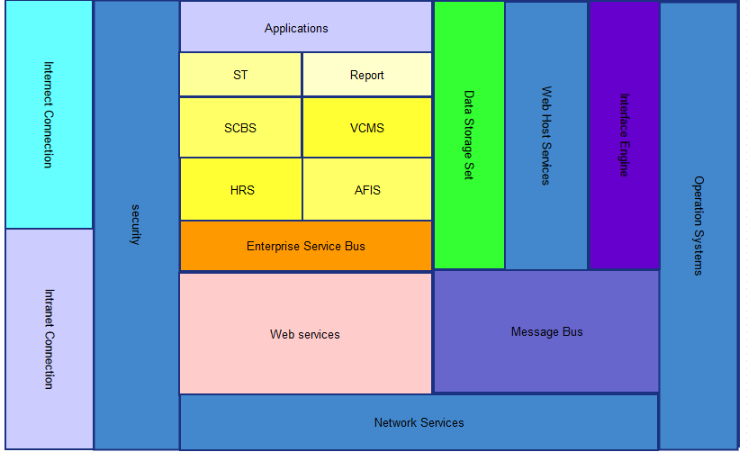

- Operation Systems
  - Basic operation service
  - Datetime synchronization service
  - File storage service
  - Host for other services
- Network service
Network service provides low lever communcation service between physical servers.It’s running at network application layer and above,provides data presentation , communication and validation using TCP/IP protocol.
To support network service for all servers, following compnents are needed:
  - Network adapter
  - Network router
  - TCP/IP Protocol
  - Other necessary component to support network connection

- Security
Security component including necessary hardware components and related software which warpe all important factors,they are
  - Hardware firewal
  - Software firewall
  - Server security components
  - Authorisation,Authentication and Access Control components
  - Log tracking
  - Encryption and Decrpytion components
- Internet connection and Intranet connection
By defination, an intranet is a computer network that uses Internet Protocol technology to share information, operational systems, or computing services within an organization. For security reason, internal project can only be accessed by intranet to protect it’s privacy.
- Message bus
Message bus, also knows as message queue, is used for interprocess communication. It uses a queue for messaging – the passing of control or of content. Group communication systems provide similar kinds of functionality. This component is using for transfer data between VCMS and SCBS.
- Web Services
The W3C defines a Web service as:a software system designed to support interoperable machine-to-machine interaction over a network. It has an interface described in a machine-processable format (specifically WSDL). Other systems interact with the Web service in a manner prescribed by its description using SOAP messages, typically conveyed using HTTP with an XML serialization in conjunction with other Web-related standards.

When any application want to open API to other parties, the request will go through web service components.
- Interface Engine
This component is using for receive message and data from web service components and message bus components and delegate to target system with certain format.
- Enterprise Service Bus
    - Monitor and control routing of message exchange between services
    - Resolve contention between communicating service components
    - Control deployment and versioning of services
    - Marshal use of redundant services
    - Cater for commodity services, i.e. Message bus, web service and network services

- Web Host service
  - Website host service
  - API host service
  - File storage service
- Data Storage Set
  - Databases
  - Replication service
  - Disater recovery service
  - Reporting generation service
- Applications
6 applications are involved: Vessel and Container Movement System (VCMS), Sales and Customer Billing System (SCBS), Account and Financial Information System (AFIS), Human Resource System (HRS), Reporting Service and Shipment Tracking Service(ST) Following services are included:
- Application UI Design Standard (IE,FF and Chrome supported)
- Application development
- Application testig
- Applicaion deployment
- Configuration Management
- Integration Services.

Technical Principles and Best Practices
Model Name | Technical Principles | Best Practise
Internet/Intranet | The appropriate security measures must be put in place to ensure security and privacy protection. | HTTP,FTP,Email Service
Security | The appropriate security measures must be put in place to ensure security and privacy protection | C2 Firewall Service  Norton Security Service
Applications(VCMS,ST,SCBS,etc) | Reuse everything that can be reused. Design and produce with reusability in mind. | Oracle-Java programming best practise
Data Storage Set | Reuse everything that can be reused. Design and produce with reusability in mind. | Oracle Database group
ESB,IE,MessageBus,Web Service | Information from across all the regional units, customers and port operators should be integrated. | Json 1.0  XML  Message Queue

Current List of Technology Architecture
SGLines Systems
 | Technology Category | Technology Standard | Brand, make and model | Applications Supported | Location | Vendor | Quality of Service | Compliance to Product Stds
1 | Customer Billing System(CBS) | Java | Oracle, Version 7 Update 21 | N/A | Unknown | SGLines | Nill | Yes
2 | Sales Order System(SOS) | C++ | Borland | CBS | Local office | SGLines | Nill | Yes
3 | Container Movement System(CMS) | Prediction Engine | Nill | SOS,CBS | High-end WinTel Server | SGLines | Have 10%-15% unscheduled downtime | Yes
4 | Human Resource System(HRS) | Java | Oracle, Version 7 Update 21 | MQ Series  Java API | AS400 Server | SGLines | Nill | Yes
5 | Account and Financial Information System(AFIS) | Java | Oracle, Version 7 Update 21 | MQ Series  Java API | AS400 Server | SGLines | Nill | Yes
6 | Vessel Movement System (VMS) | C++ | Borland | CMS,SOS  CBS | High-end WinTel Server | SGLines | Have 10%-15% unscheduled downtime | Yes
7 | SGLine Website | HTML 4.0 | N/A | N/A | Local ISP | SGLines | Nill | Yes

Target List of Technology Architecture
SGLines Systems
 | Technology Category | Technology Standard | Brand, make and model | Applications Supported | Location | Vendor | Quality of Service | Compliance to Product Stds
1 | Operation System Services | Linux | Redhat Linux | Application Services | Cloud | Redhat | 99.9999%  Available | Yes
2 | Network Services | IEEE802 | Starhub | Application Services | Telecom | Starhub | 7x24 online | Yes
3 | Security | Firewall | C2 Hardware Firewall  Norton Software firewall | Application Services | Cloud | C2, Norton | Enterprise support | Yes
4 | Interface Engine | Java, XML,Json | Oracle Java Version7 ,  XML 1.0 5th Edition,  Json 1.0 | API Service | Server | SGLines | 7x24 Available | Yes
5 | Web Service | XML,SOAP | W3C | API Service | Server | SGLines | 7x24 Available | Yes
6 | Data Storage Set | T-SQL Standard | Oracle 11i | Application Services | Data Center | SGLines | 7x24 Available | Yes
8 | Web Host Service | HTTP,HTTPS | W3C,Apache Web Server | Web applications | Cloud | SGLines | 7x24 Available | Yes
9 | Applications  ST  Report  SCBS  VCMS | Java,MVC,Javascript,  HTML5.0, CSS3 | Oracle 11i  W3C | NA | Server | SGLines | 7X24 Available | Yes

List of Stakeholders and their Concerns
Stakeholder | Concerns | View
Customer | Easy to access the web site  Easy to access on-site data  Able to direct RFQ, ordering and calculation shipment time online  Security | Conceptual Data Model
IT Staffs | Able to maintain the system easily.  Able to add new futures to current system | Target Technology Architecture
Sales Team | One-site access. Don’t want to access different system to complete one task. | Target Technology Architecture
Order processing  Administrator | More user-friendly and easy to use system | Target Technology Architecture
Management team | Real time report. | Target Technology Architecture
Port operator | Able to determine optimal container movement and placement within a vessel by web services. | Target Technology Architecture

Current and Target Technology Architecture
Current technology architecture provides the hardware level diagram.
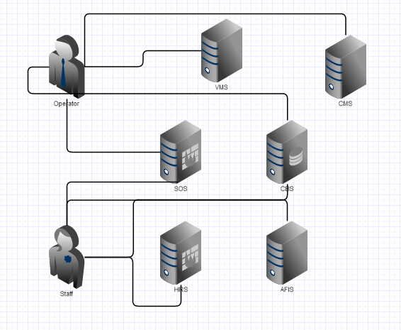

The target technology architecture gives an overview of the proposed system level design that the EA should be consolidated to.
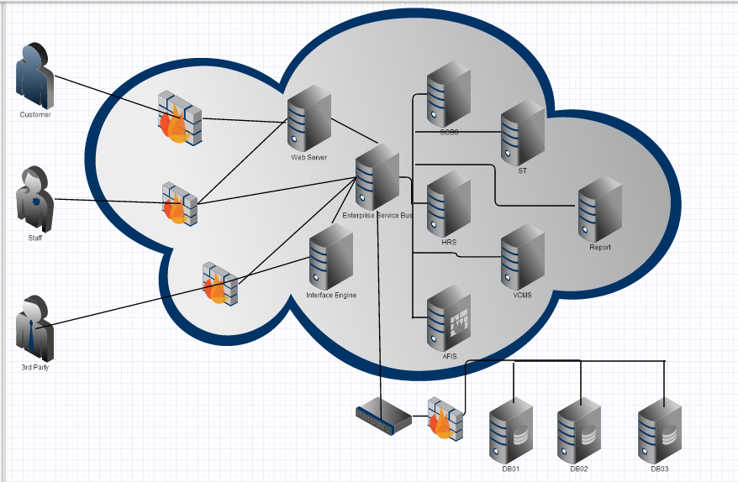

List of Technology Architecture Gaps
Gap | Description | Current State | Future State | Importance/Benefit | Address by Architecture
Gap 1 | Security Issue | No firewall found | Everything will hide under firewalls | Increase security | Technical
Gap2 | Load Balance/High speed cache not present | Not mention LB | Will include in ESB | Increase stability and performance | Technical
Gap3 | No global data centre found | No plan for data centre | Will consider to set up | Increase loading speed for global user | Technical, Applicatin,Business

